BUILD RELEASE FORM

Product Name | Gamification
Version Number | 1.2.0
Repo URL | https://dev.azure.com/SterlingAppsDevOps/Gamification/_git/Gamification_frontend
General Description | Gamification

\

- CONTENTS OF THIS BUILD/apk
 | Description | Implementer’s test evidence (Screenshot/Logs/Links)
User Dashboard caption and Card fix | 1.fixed the landing page grammatical error. Now changed to “Great Job! To are (position number) o the Gamification Leader Board. | 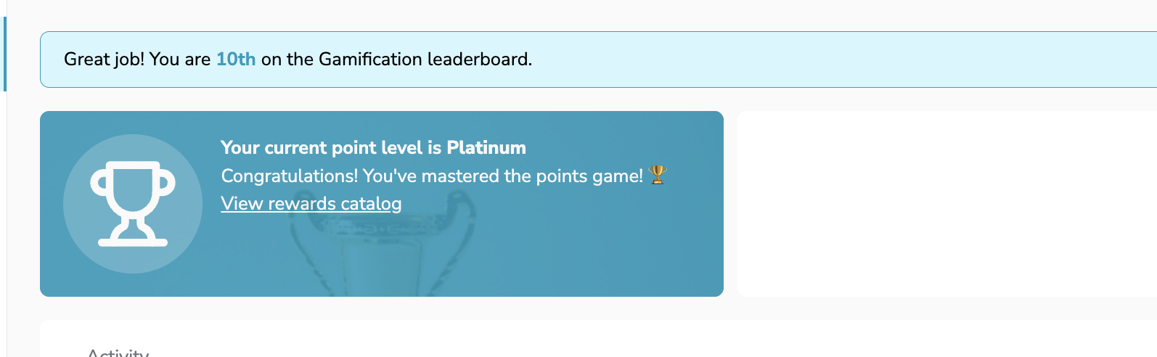
Total point fix | 2.changed “Total scores breakdown” Total points Breakdown” as requested | 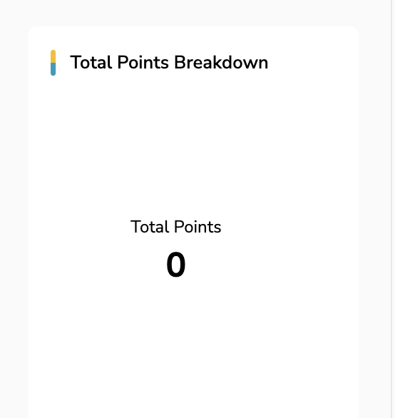
Point level fix | 3. Changed “Your Score Level “to” Your Point Level” | 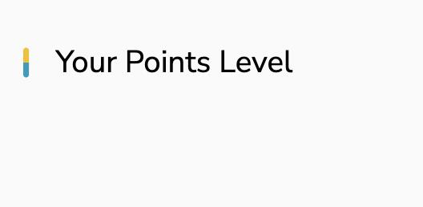

- BRANCH(ES) THIS BUILD HAS BEEN CHECKED INTO
development

- BUILD RELEASE PURPOSE
FOR NEW APPLICATION | Yes No N/A
FOR CODE MODIFICATION/REFACTORING | Yes No N/A

- CODE MODIFICATION/REFACTORED

# | BEFORE | AFTER
1

- ENGINEERING COMPLIANCE CHECKLIST

- DEPENDENCIES
9 | Any Other Dependencies

- DEPLOYMENT NOTE
To deploy this artifact(s) to production, please take the following steps:
1. Merge development branch to release branch
2.
3.
4.
5.

- ROLLBACK PLAN
In event of a necessity to execute a roll back to previous states after deployment, please take the following steps:
1. Revert merge
2.
3
4.
5.

- DEPLOYMENT SUPPORT PERSONNEL
If technical assistance is required before, during or after deployment, please contact the following:
Name | Phone | Email
Oghenerukevwe Sandra Idjighere | 07080289874 | Oghenerukevwe.Idjighere@sterling.ng

- ATTESTATION
The codebase/stored procedure/database scripts for this implementation have been duly reviewed by my Line manager/Team Lead (undersigned). Yes No

- REVIEW AND APPROVAL
Action | Name | Designation | Signature | Date
Prepared By (Developer) | Oghenerukevwe Sandra Idjighere | Frontend Developer |  | 03/03/2025
Approved By

Security Notice: The information contained within this document is CONFIDENTIAL. Unauthorized disclosure is prohibited. Failure to observe Sterling Bank guidelines regarding proprietary information can result in disciplinary action, including dismissal, and can subject you and/or third parties to legal liability.

Handling Guidelines: (Tick all that apply)
Do not forward or copy data in part or full without explicit permission of Sterling Bank Plc
Limit access to individuals on Access List / Lock in a Drawer / Cabinet.
Password-protect when emailed outside Sterling Bank’s Network / Send password separately

